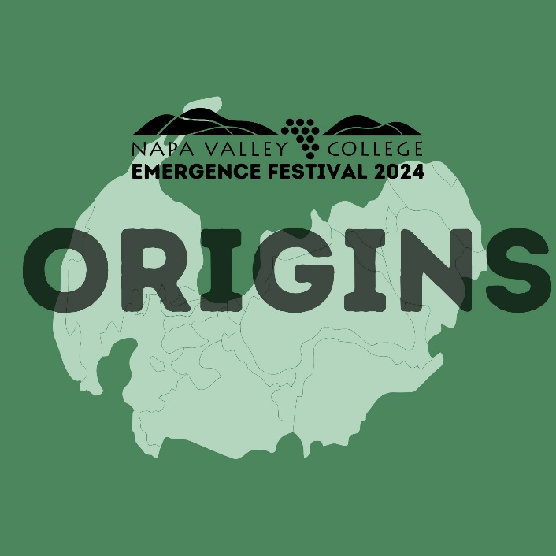
Emergence Festival 2024

OVERVIEW
Nothing emerges from the ether fully formed. Everything that is has been shaped by that which came before it. Every story told can be understood in a new way as it is heard with new ears and spoken by new voices. Your ears. Your voices.

The Napa Valley College Emergence Festival is a celebration of voices built each year around a central theme. This year, we ask NVC Students, Staff and Faculty to share their original works on the theme of ORIGINS.

Art is subjective and often is based on personal experiences, opinions, beliefs, and feelings rather than on agreed and established facts. The Emergence Festival of New Works allows for your artistic work to be shared. Your work/s might include: paintings, drawings, sculpture, photography, film, play/monologue, spoken word, written poetry, song, or music composition.

The Faculty of the NVC Performing Arts and Visual Arts Departments will serve as curators for this event. Performing Artists whose works are chosen for this year's Festival will be invited to develop their pieces in workshop with Faculty in preparation for the live event taking place on February 9, 10 and 11, 2024.

TO APPLY
To apply you must be Napa Valley College students, alumni, staff or faculty members. The work of art must incorporate Origins as a major theme. Performance and Film work must be under seven minutes in length.
Applicants may perform sections of their works to fulfill the time limit requirement.
The application deadline is November 1, 2023.
Submit your application via the online form: https://forms.office.com/r/777Mw7jrFp.
You may also email your form as an attached Word or PDF document to Performing Arts Administrative Assistant, Yessenia Anguiano at Yessenia.Anguiano@napavalley.edu.
APPLICATION
Answer the following prompts in a Word or PDF document. Save and title the document with your last name followed by Emergence (for example, if you name is Martinez you would title the document MartinezEmergence).
When emailing your application, in the Subject line type EMERGENCE in all caps.

Project Leader:

Are you a student, alum, staff, or faculty?

If you are a student, have you declared a major? If so, what is it?

Email:

Cell Phone:

Describe project and how it links to the theme of “Origins” (50 words or less):

Who are the members of your creative team? (Examples: If you are a solo artist, you would list your name. If you have multiple people involved as directors, actors, designers, dancers etc., list all of their names)

_____________________________________________________________________

Project Information

Working Title:

What performing arts medium are you exploring? (circle one)

Play*

Monologue

Dance Piece

Devised Work

Song

Film

Spoken Word

Instrumental composition

Other (describe)

*Please note that some plays may receive readings.

Describe your development process. What has already been done and what further development will need to happen between now and the presentation of the work?

What production elements are required to produce your work?

Is there anything else we should know?

If you gave your piece a film rating (PG, PG-13, R, etc.), what would it be?

For performers:
What is the length of your performance?

How much rehearsal time will you require?

PROPOSAL APPLICATIONS ARE DUE November 1, 2023 BY 5PM
Submit to Yessenia.Anguiano@napavalley.edu
If you have any questions, reach out to Jennifer King, Theater Arts Coordinator, at jking@napavalley.edu
Proposal applications may be submitted prior to the due date.

The Emergence Festival will be presented February 9, 10 and 11, 2024

